**CSC 370 – Database Systems**

Dr. Sean Chester

**Movie Rating System**

Project Sprint: 2

June 12th, 2024

Team27J

Alyssa Taylor V00987477

Karan Gosal V00979752

For the Course Level Competency, we are currently at ***Level-2*** for both *Data*

*Modelling* and *Data Analytics* as we have mostly accomplished these.

Considering the information from the competencies from lecture, in detail:

We have achieved Level 2 proficiency in Data Analytics. In SQL, we can transform data for visualisation using slicing, dicing, pivoting, and aggregation. We have mastered expressing complex logic through single SQL queries, understanding how dependencies and integrity affect query semantics, and effectively managing operators in nested queries. Additionally, we have also achieved Level 2 data modelling, constructing well-normalized conceptual and relational schemas that accurately capture requirements without redundancy. By effectively normalizing, we eliminate data anomalies. We identify dependencies among attributes and select appropriate identifiers/keys for entity sets and relations. We justify the quality of a schema through a theoretical lens. We map requirements onto schemas and vice versa to ensure designs are minimal and complete.

By the **end of the next Sprint** i.e., Sprint 3, We will cover some parts of ***Level-3*** for *Data Analytics* and ***Level-1*** for Back-end Engineering.

From Level-3 Data Analytics, we will look into **indexes**, which are essential for enhancing data retrieval efficiency and query performance by reducing the time and resources required to locate specific data.

From Level-1 for Back-end Engineering, we will also explore **views** in SQL, understanding how to create, modify, and query views to control data access and simplify complex database operations. This includes using views as subqueries, performing joins, and managing data modifications through views.

We will also explore the **ACID properties**—Atomicity, Consistency, Isolation, and Durability—essential for ensuring data integrity and reliability in transactional database systems. We will learn how these properties support the execution of reliable and consistent **transactions**, allowing us to maintain data integrity and recover from failures effectively.

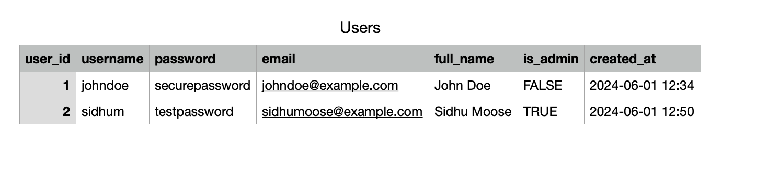

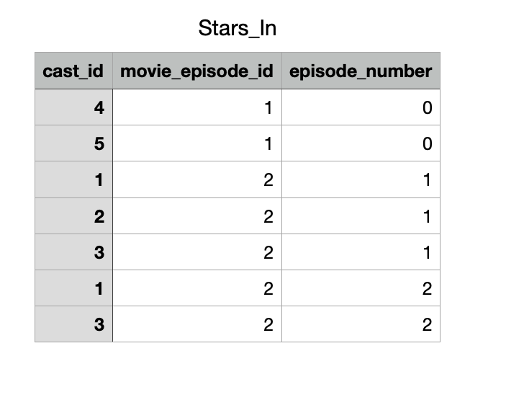

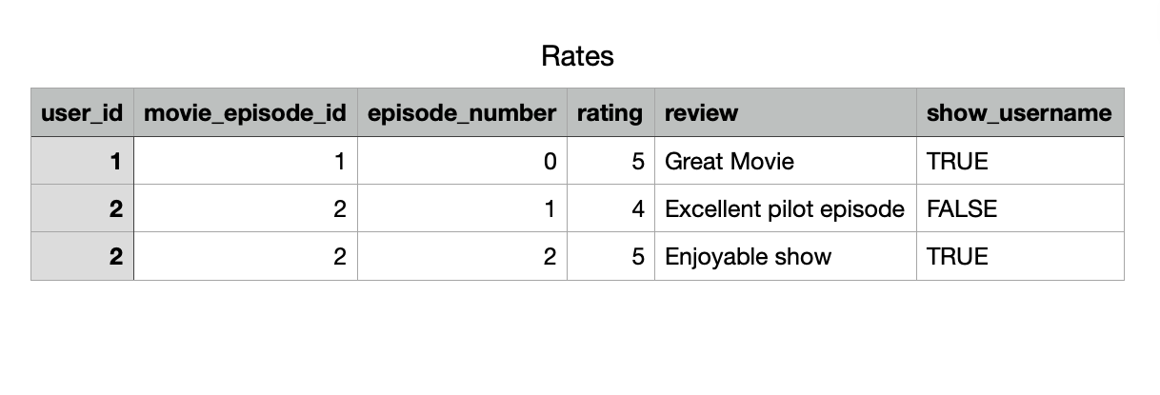

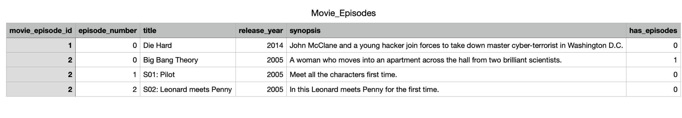

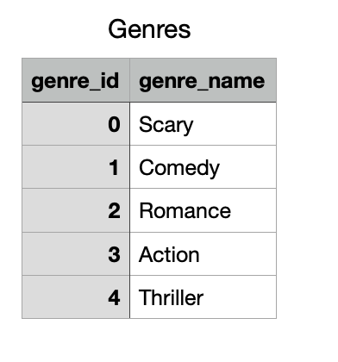

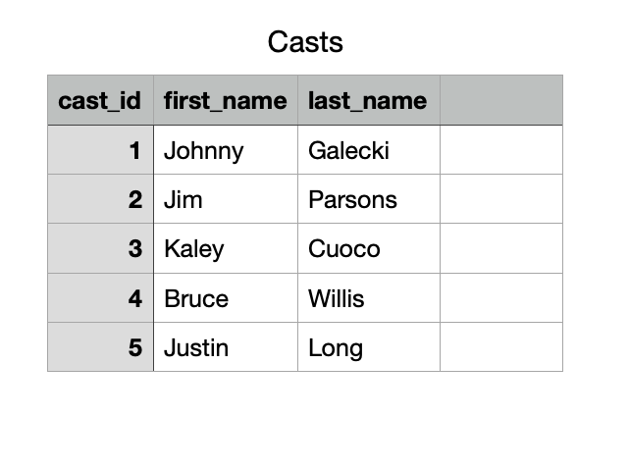

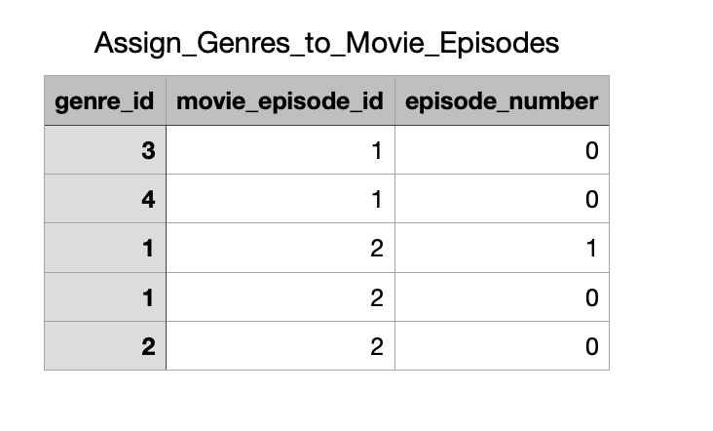

All the tables above represent the tables that follow our ERD schema and in the past sprint we have covered the basics for creating tables and creating tuples using the information from the CSV files or manually using INSERT SQL commands. Here is our ERD just in case.  
  
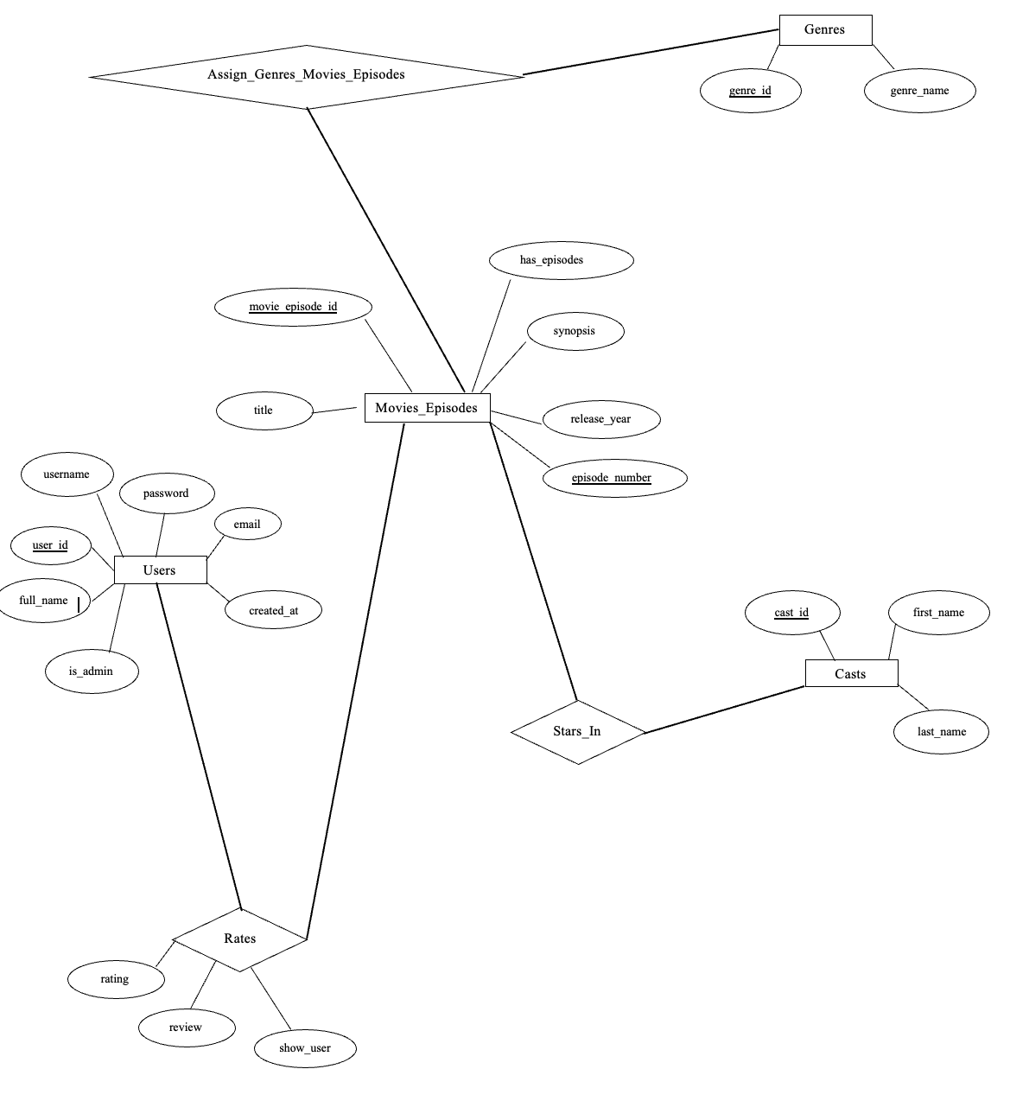

**DATA ANOMALIES:**

1. **Redundancy -** Redundancy occurs when information is needlessly duplicated. In our case, we have a design that is redundancy free as evident by the example tuples from above.
2. **Insertion Anomaly** - Insertion anomaly refers to the possibility of introducing data errors or violating database design when inserting new tuples.

Currently, we don’t have any foreign key references. So, there is a chance of insertion anomaly in our tables. For example, if we add some entry inside the **Rates** table with some random ***user_id*** which does not exist in the **Users** table.

1. **Updation Anomaly** - Update anomaly occurs when modifying information could lead to inconsistencies in the data.

Currently, we don’t have any foreign key relations. So, there is a chance of updation anomaly in our tables. For example, if we update some entry inside the **Rates** table for ***user_id***, then we have different values in the **Rates** table compared to the **Users** table.

1. **Deletion Anomaly** - Deletion anomaly happens when removing information could result in losing other related information as well.

Here in our case as we don’t have foreign key references yet, if we delete some entry from the **Users** table which was used in some other table, we would lose all the information about the user as we are just using ***user_id*** in other tables for example **Rates** Table.

**FUNCTIONAL DEPENDENCIES:**

Functional dependencies are constraints between attributes in a relation (or table) that describe the relationships between those attributes. We have four Entities - **Users, Movies_Episodes, Genres, Casts**. So, we need to consider the Functional Dependencies in these. The main purpose of identifying functional dependencies is to ensure that the database is normalized and that it adheres to certain design principles.

**Users**

user_id -> username, password, full_name, email, is_admin, created_at

username -> user_id, password, full_name, email, is_admin, created_at

email -> username, password, full_name, user_id, is_admin, created_at

Candidate keys: {user_id}, {username}, {email}.

Primary key: {user_id}

Closures:

{user_id} ${ ^{+}}^{}$ = {username, password, full_name, email, is_admin, created_at, user_id}

{username} ${ ^{+}}^{}$ = {username, password, full_name, email, is_admin, created_at,

user_id}

{email} ${ ^{+}}^{}$ = {username, password, full_name, email, is_admin, created_at, user_id}

**Movies_Episodes**

movie_episode_id , episode_number -> title, has_episodes, synopsis, release_year

Closures:

{movie_episode_id , episode_number} ${ ^{+}}^{}$ = {movie_episode_id , episode_number,

title, has_episodes, synopsis, release_year}

Candidate keys: {movie_episode_id, episode_number}

Primary key: {movie_episode_id, episode_number}

**Genres**

genre_id -> genre_name

genre_name -> genre_id

Closures:

{genre_id} ${ ^{+}}^{}$ = {genre_id, genre_name}

{genre_name} ${ ^{+}}^{}$ = {genre_id, genre_name}

Candidate keys: {genre_id}, {genre_name}

Primary key: {genre_id}

**Casts**

cast_id -> first_name, last_name

Closures:

{cast_id} ${ ^{+}}^{}$ = {cast_id, first_name, last_name}

Candidate keys: {cast_id}

Primary key: {cast_id}

By checking all the functional dependencies and computing closures(the maximum set of attributes that can be identified from one attribute), we can say all of our functional dependencies fulfil the conditions for the BCNF. **Every determinant must be a candidate key**: A determinant is an attribute (or a set of attributes) on which some other attribute is fully functionally dependent. In BCNF, for every non-trivial functional dependency X→Y, X must be a superkey (a candidate key). This is true for all of our functional dependencies. Therefore, we can say **all of our tables are in BCNF** and we don’t need any decomposition(breaking up the table into more than one table due to BCNF violation) of the table.

We have incorporated some rules out of these few logical rules for the closures:

1. **Combining rule**: For example

user_id -> username

user_id -> password

After combining:

user_id -> username, password

1. **Splitting rule**: For example

user_id -> username, password

After splitting:

user_id -> username

user_id -> password

1. **Transitivity rule**: For example

user_id -> username

username -> password

Using transitivity:

user_id -> username, password

1. **Triviality rule**: For example

username -> username, password

1. **Semi-triviality rule**: For example

username -> username, password

Simplified as:

username -> password

**LOSSLESS DECOMPOSITION AND NATURAL JOIN:**

Since our tables are in BCNF and we already have a lossless decomposition. We can perform the natural join on the tables to get the whole picture of the tables if they were combined.

SELECT * FROM Casts NATURAL JOIN Stars_In;

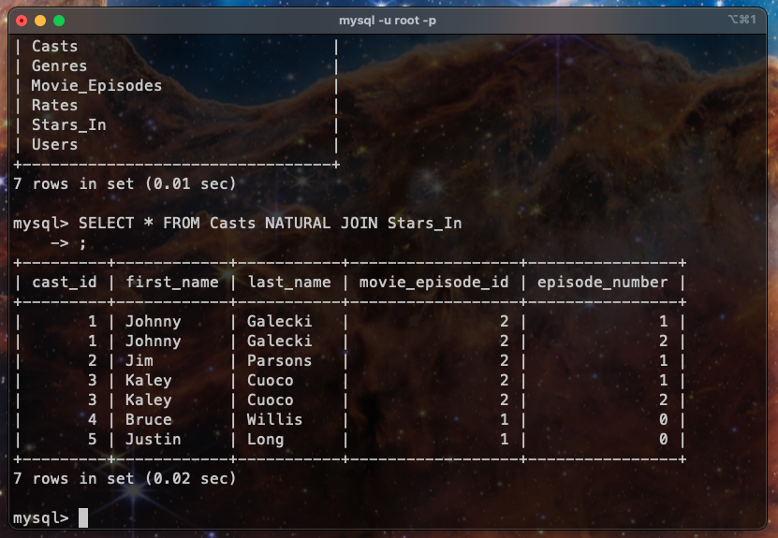

**CONSTRAINTS AND REFERENTIAL INTEGRITY:**

CONSTRAINTS

Since this is a complex database system with personal user data and complex possible queries, many constraints need to be included in order to keep data anomalies and running errors to a minimum. We have decided on some basic constraints below and have written them in their equivalent relational algebra definition:

* Every account has a Unique email
* Every account has a Unique username
* Every genre has a Unique name
* Ratings are Bound between 0 and 5

**Relational Algebra Constraint Definitions**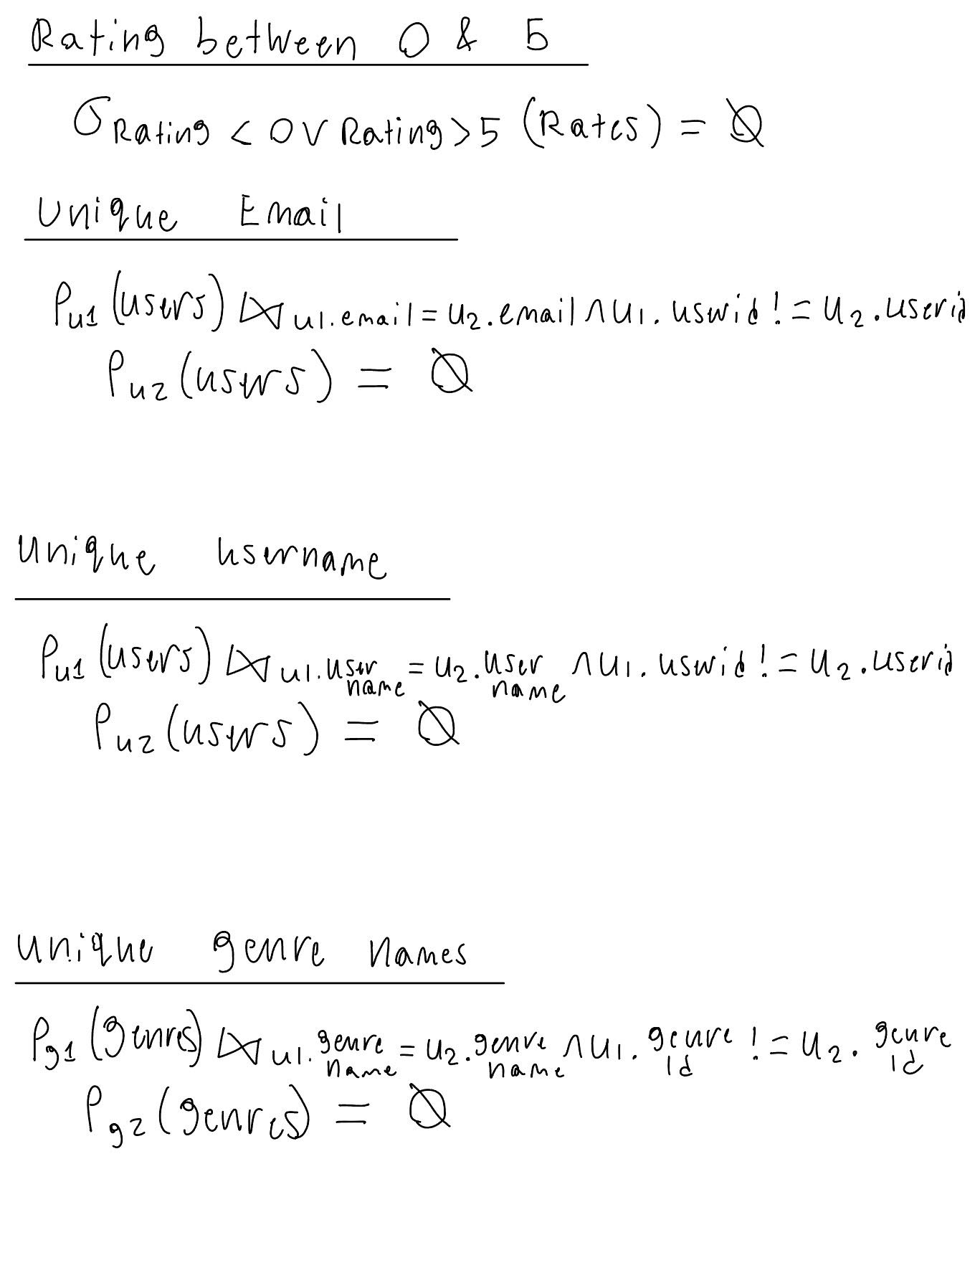

ALTER Table making attributes unique:

Before -

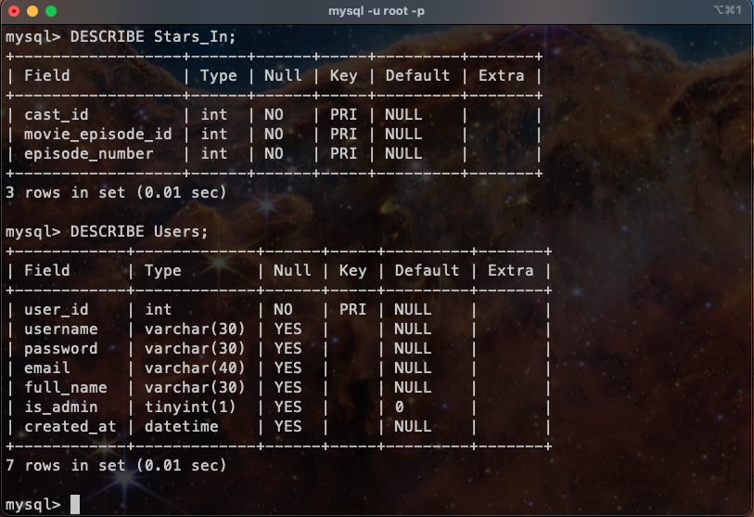

ALTER TABLE `Users` ADD UNIQUE (`username`), ADD UNIQUE (`email`);

After -

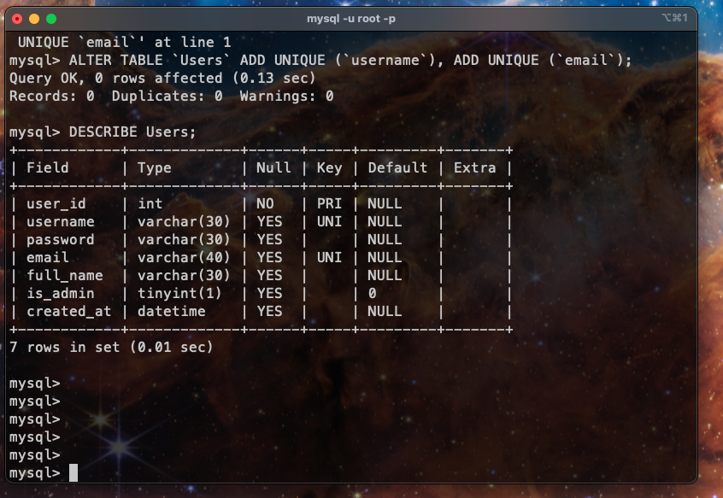

Similarly, this can be applied on the **Genres** table as we want ***genre_name*** to be unique.

Adding Constraint to the Rating table, so the rating must be between 0 to 5 included.

ALTER TABLE `Rates` ADD CONSTRAINT `check_rating` CHECK (`rating` >=0 AND `rating` <=5);

Proof of its working:

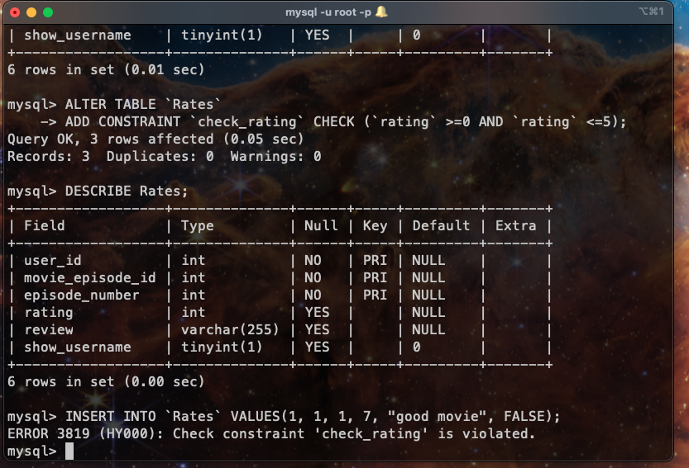

FOREIGN KEYS:

Adding the foreign key to **Rates** table referencing ***user_id*** from **Users** table.

ALTER TABLE `Rates` ADD FOREIGN KEY (`user_id`) REFERENCES `Users` (`user_id`);

ALTER TABLE `Rates` ADD FOREIGN KEY (`movie_episode_id`, `episode_number`) REFERENCES `Movie_Episodes` (`movie_episode_id`, `episode_number`);

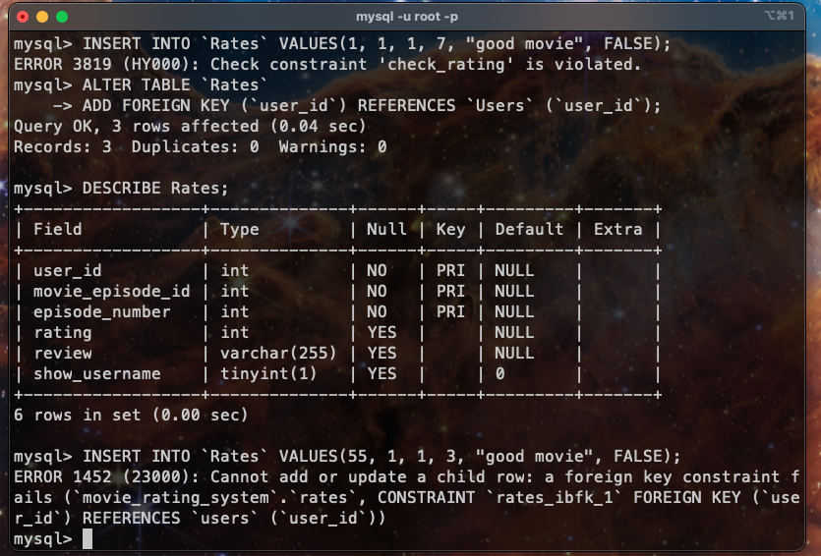

Similarly adding reference for the other tables. The queries can be found in the sql

files in the repo folder. 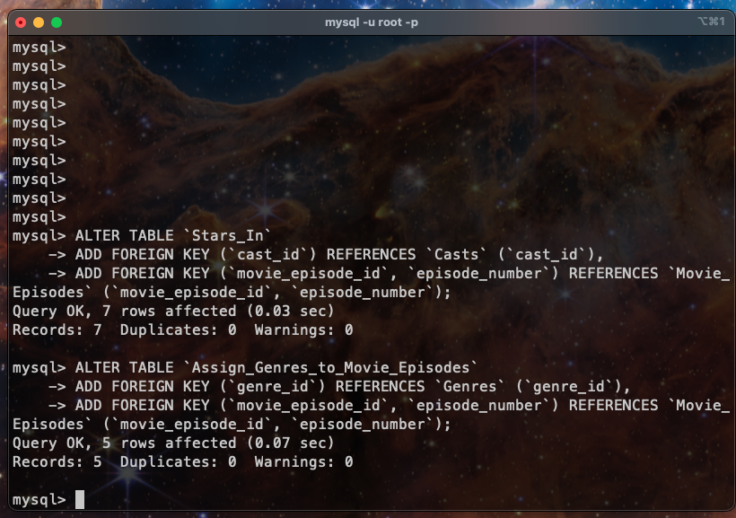

**GROUPING AND AGGREGATION:**

Equivalence Classes - DISTINCT, GROUP BY

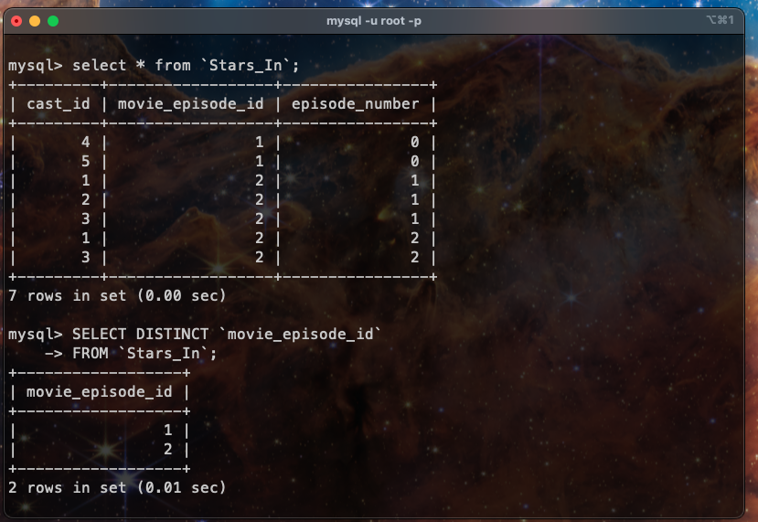

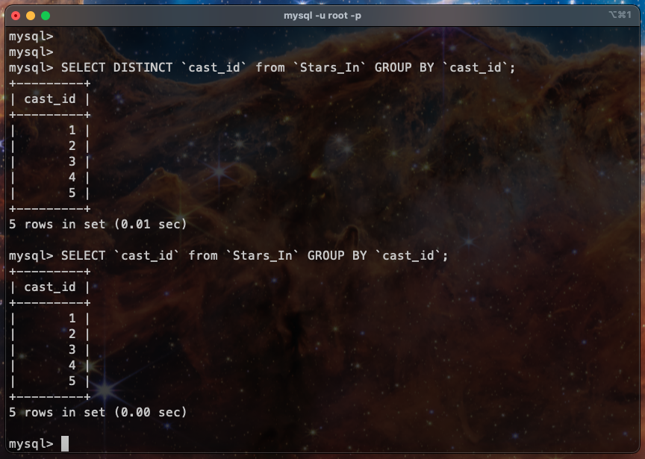

AGGREGATE FUNCTION:

Convert values to scalar - MIN, MAX, AVG, SUM, COUNT, ANY

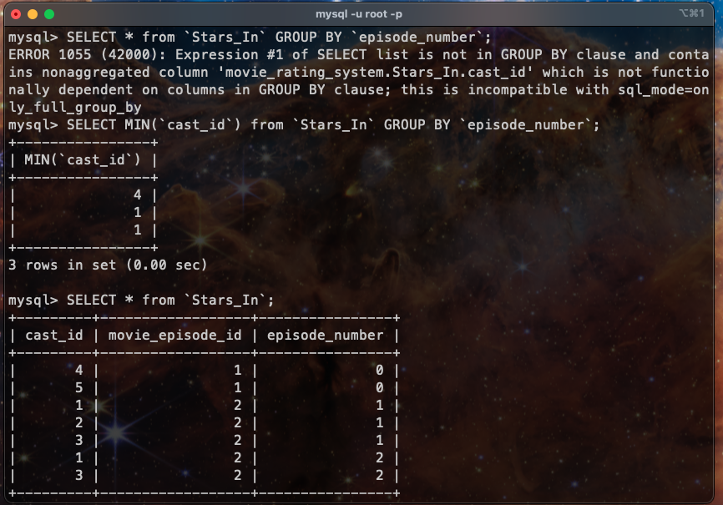

More queries can be found in the sql file in the repo.

HAVING CLAUSE:

Casts that have performed more than once in any show.

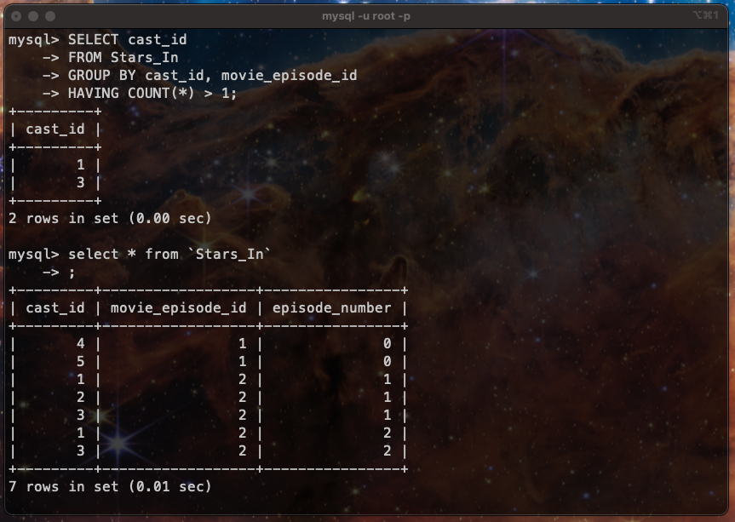

LIKE:

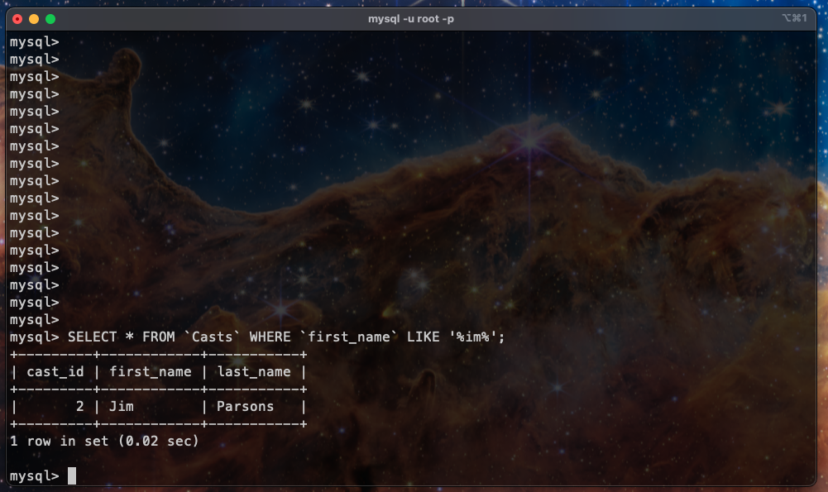

USE CASES AND COMPLEX QUERIES:

As a public movie rating system, this web app is usable by many different types of users, such as administrators, new users (no account), and full users (has an account).

Below are some of the basic level actions that would need to be included in order for this application to work as intended. The important information from each use case statement such as user-type, action, and impacted data are all bolded to easier understand each scenario. The highlighted points are complex queries demonstrated below:

1. **Admin** can see which **Users** have **rated** the most **films**
2. **User** and **Admin** can **see** which **actors** have starred in the most **films**
3. **User** and **Admin** can **see** the highest **rating** a **user** has given
4. **User** and **Admin** can **see** the **films** an **actor** has **starred in (**in one show)
5. **User** and **Admin** can **see** the **title** of **films** with specific **ratings**
6. **User** and **Admin** can **see** the highest **rating** a **user** has given
7. **User** and **Admin** can **add** a **review**
8. **Admin** can **change** a **film title**
9. **User** and **Admin** can **search** for a **specific film**
10. **Admin** can **add** a new **film**
11. **Admin** can **delete** a **film/TV show** and all its **data**

**Real use cases using complex queries:**

1. Get the display names of users who have rated the most episodes.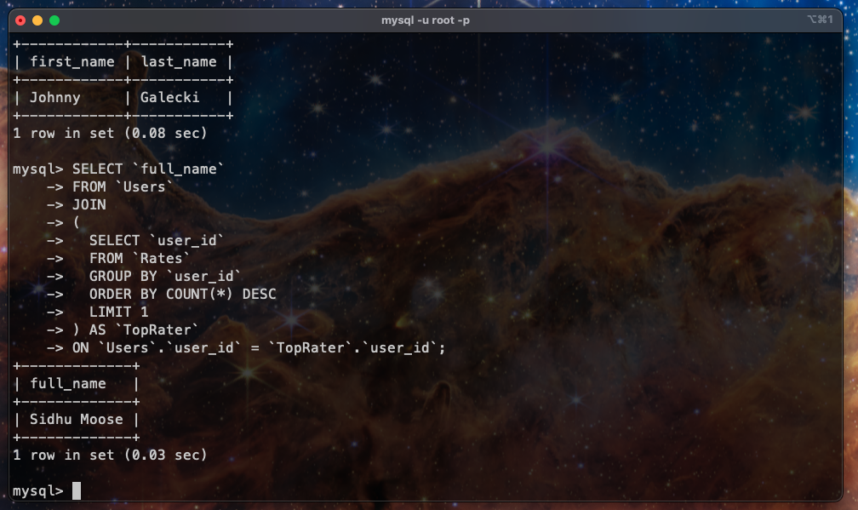
2. Get the cast members who have starred in the most episodes.

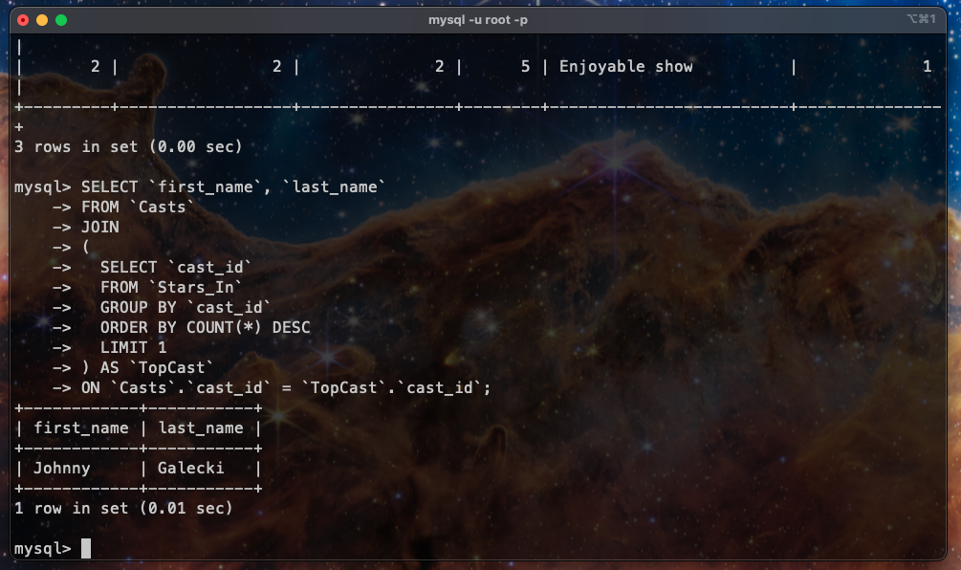

1. For each user, get the highest rating they have given.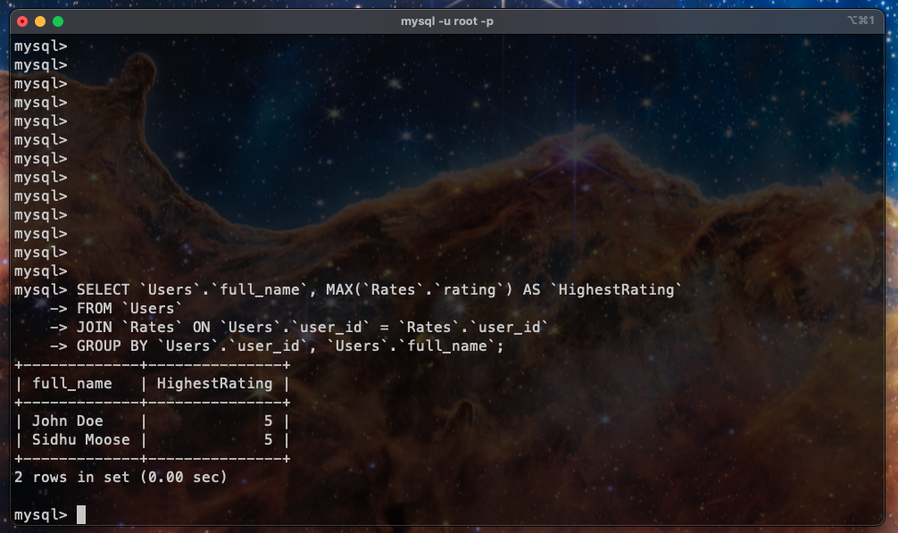
2. For each cast member, get the maximum number of episodes they have starred in one show.

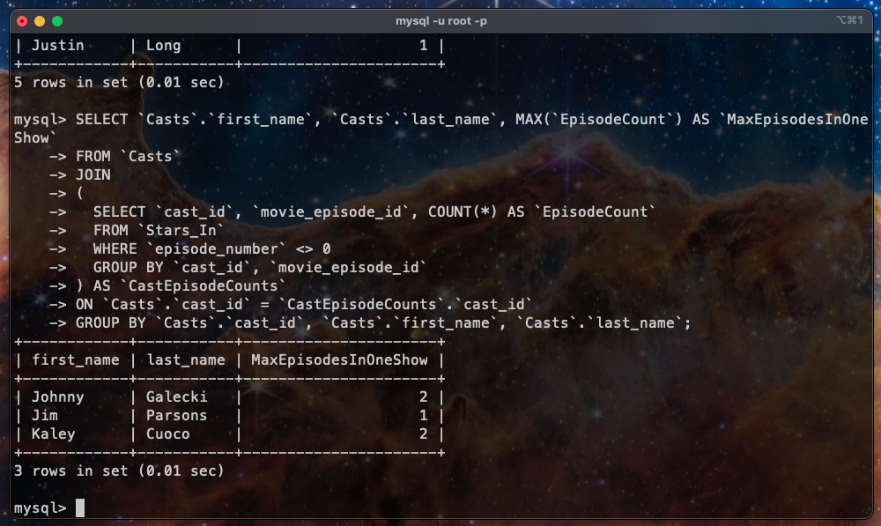

1. Get the title of the shows or movies with rating 5.

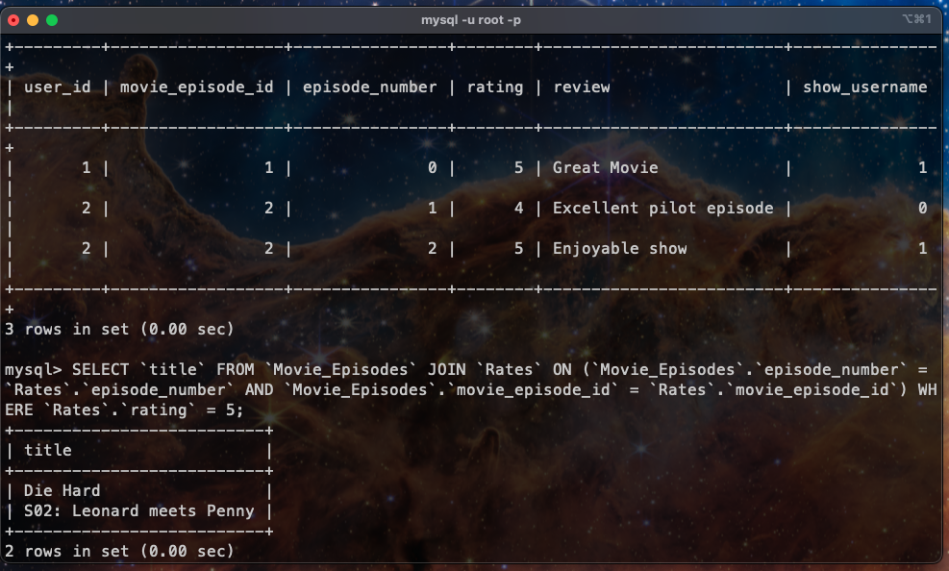

1. Get the Cast Members Not in Die Hard.

